Supporting: MSFKB3003 Check and measure fit of cabinets

Section 1 Assignment: Checking measurements
Name |  | Date

Task 1
Drawing 1 below shows a wall in a kitchen, with hot and cold water pipes and power for the dishwasher power point. The cabinet installer has measured where the services are in terms of the left hand wall and the finishing line (top) of the cabinet carcases. Drawing 2 shows the layout lines for the cabinets, together with their names and width dimensions. Drawing 3 (next page) shows the sink cabinet, viewed from the back.
Work out where the centre points will be for the three holes in the back of the cabinet. Write your answers in the boxes provided on Drawing 3 on the following page.
Drawing 1
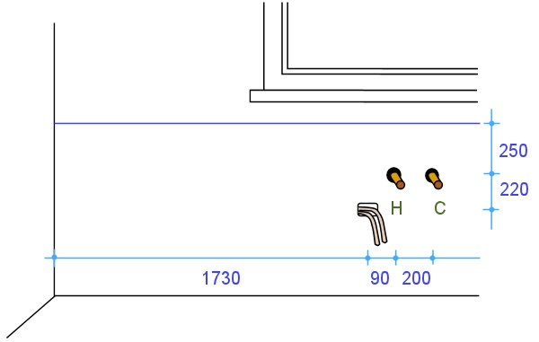

Drawing 2
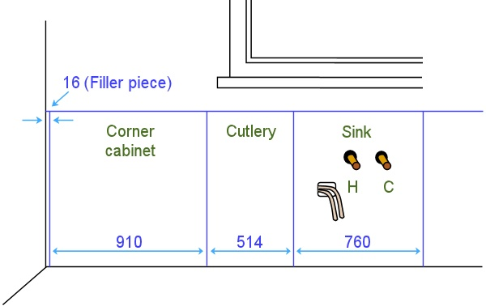

Drawing 3
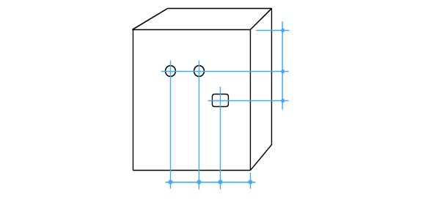
Note that the positions of these holes are reversed in relation to the view of the wall, because you are looking at the back of the cabinet.

Task 2
Assume that you have been asked to check all relevant measurements on one wall of a kitchen or bathroom, in preparation for a new installation. Your task is to produce a freehand sketch of that wall in elevation view, showing all required features and measurements.
The wall you choose to draw up may be in a building where you are installing a kitchen or bathroom. Or it may be in your own home or a friend’s home, if you don’t have access to a jobsite. Do not show any existing cabinets or other fittings – you should assume that these will be demolished before the new installation begins.
The wall should include the following features as a minimum: a door, a window and water pipes for taps. It may also include other features, such as power outlets, columns, bulkheads and any other architectural features.
You may use symbols and abbreviations in your elevation sketch, but all details must be clear to others who might need to consult the drawing, and all relevant measurements must be easily identifiable.

Completing this assignment
Note that there is no template for Task 2 above. If you are producing your drawings in hard copy, you should slide the separate pages into your workbook. Don’t forget to put your name and details on the top of the page.

